Technical Report: Our EV Energy Consumption Model (V2)

1. Problem Statement
Our goal is to accurately predict how much energy an electric vehicle (EV) uses during a trip. This is a major challenge because real-world driving involves a complex mix of physics and unpredictable factors like weather. We want to minimize these errors to provide drivers with a truly reliable range prediction tool.

2. What We Added (Comparison: V1 vs. V2)
To move from a basic theoretical model (V1) to a "Digital Twin" (V2), we enriched our dataset with several key elements:
- Real Efficiency Curves: Instead of using a fixed percentage, we integrated real-world data curves from Renault. These allow us to calculate efficiency based on motor speed ($\eta_{pt}$) and battery temperature ($\eta_{bat}$).
- Environmental Context: We added a rain_proxy to detect if the road is wet or dry and included the outside ambient temperature.
- Vehicle Load & State: We now include the payload_kg (weight of passengers/luggage) and the SOC_pct (current battery level) to make our physics calculations more realistic.
- Auxiliary Power: We integrated the real power used by the car's electronics (P_aux_load_kW) directly from OBD-II data.

3. Methodology: Our Data Process
We processed this data through a two-step hybrid "Grey-Box" approach:

A. The Physics Core (Deterministic Model)
We used the raw data to calculate the physical forces slowing the car down:
- Aerodynamics: We calculate the force of air against the car. We added a "corrector" (2.2) because real-world air is never perfectly still.
- Rolling & Gravity: We calculate tire friction based on road conditions (wet/dry) and the energy needed to climb hills using elevation changes.
- Inertia: We used a corrector (0.4) for acceleration to better match real-world friction and tire grip.

B. Machine Learning (The Calibration Layer)
Even with good physics, our initial model had a 9.83% error. To fix this, we used an XGBoost Regressor.
- What it does: Instead of predicting everything, the AI only predicts the mistake made by the physics model.
- The Logic: Our final result is the sum of the physics calculation and the AI's correction: $E_{hybrid} = E_{physics} + \text{AI Correction}$.

4. Results & Analysis
Comparing our model to real trip data showed a massive jump in precision:
Metric | Physics Model (V1) | Our Hybrid Model (V2)
Error (MAPE) | 9.83% | 0.91%
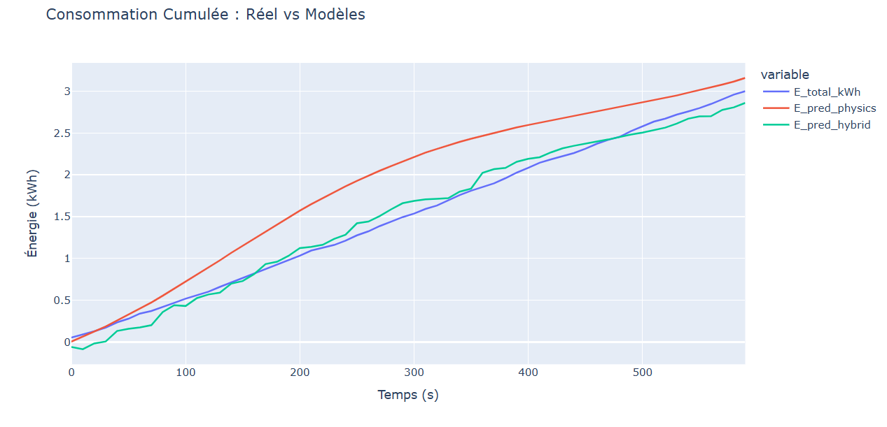

Perfect Alignment: Our "Parity Plot" shows that our predictions now align almost perfectly with actual measurements.
Stability: The error stays near zero throughout the trip, meaning our model doesn't "drift" or get lost over long distances.

5. Points for Improvement
To make our Digital Twin even better, we have identified these next steps:
- Heating & Cooling: We plan to add a sub-model for the HVAC system (Heating/Air Conditioning), as it is a huge energy consumer depending on the weather.
- Battery Health (SOH): We want to use the small remaining errors to detect "Battery State-of-Health" degradation over time.
- Braking Regeneration: We currently estimate energy recovery at 70% during braking. We could refine this by using real-time motor torque data.
- Real-Time Integration: Our next goal is to optimize the code to run live inside the vehicle, updating the range every second based on current driving.

